|  |
| --- |
| Description: E:\My Documents\Desktop\Logo_FPT_University_doc.jpg |
| Report 6b: User’s Guide |
|  |
|  |
| |  |  | | --- | --- | | **OOPMS Team** | | | **Group Members** | NgôĐức Duy – 60163  PhạmNguyễnTrườngGiang – 60132  TôCông Thanh Hải – 60140  MạnhHoàngTrương – 60003 | | **Supervisor** | Teacher LêNgọcThạch | | **Project Code** | OOPMS | | **Document Code** | OOPMS\_User'sGuide\_v1.0 | |
| **Ho Chi Minh City, 20thJul, 2012** |

**Record of Changes**

|  |  |  |  |  |
| --- | --- | --- | --- | --- |
| **Date** | **Change Item** | **Description** | **By** | **Version** |
| 04/08/2012 | Create outline | Create the outline document | DuyND | 0.1 |
| 08/08/2012 | All | Update | DuyND | 0.2 |
| 09/08/2012 | All | Update | DuyND | 0.3 |
|  |  |  |  |  |
|  |  |  |  |  |
|  |  |  |  |  |
|  |  |  |  |  |
|  |  |  |  |  |
|  |  |  |  |  |
|  |  |  |  |  |
|  |  |  |  |  |

# Table of Contents

[Table of Contents 170](#_Toc332229113)

[1. General Guide 171](#_Toc332229114)

[1.1 Log in 171](#_Toc332229115)

[1.2 Log out 171](#_Toc332229116)

[2. User Guide (Developer/Tester/QA) 171](#_Toc332229117)

[2.1 View Projects 171](#_Toc332229118)

[2.2 Join Project 171](#_Toc332229119)

[2.3 View Product 171](#_Toc332229120)

[2.4 View Requirement 171](#_Toc332229121)

[2. 5View Planner 171](#_Toc332229122)

[2.6 Add Timesheet 171](#_Toc332229123)

[2.7 Update Timesheet 171](#_Toc332229124)

[2.8 Log Defect 171](#_Toc332229125)

[2.9 Assign Defect 171](#_Toc332229126)

[3. Project Manager Guide 171](#_Toc332229127)

[3.1 Create Project 171](#_Toc332229128)

[3.2 Add team member 171](#_Toc332229129)

[3.3 Add Requirement 171](#_Toc332229130)

[3. 4 View Timesheet 171](#_Toc332229131)

[3.5 View Defects 171](#_Toc332229132)

[4. Admin Guide 171](#_Toc332229133)

[4.1 Create User 171](#_Toc332229134)

### General Guide

#### Log in

#### 1.2 Log out

### User Guide (PM/Developer/Tester/QA)

#### 2.1 View Projects

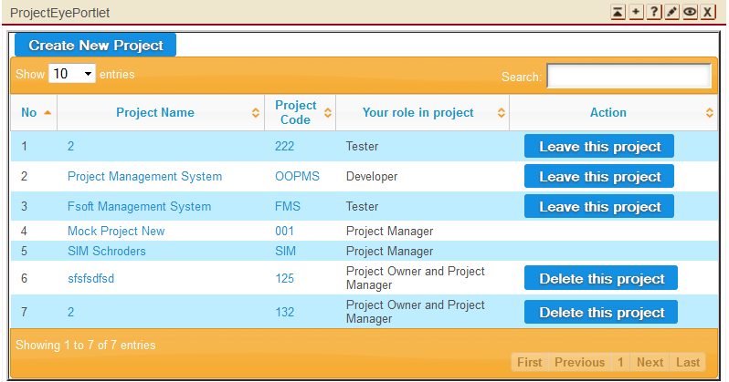

##### 2.1.1 Create Project

##### 2.1.2 Update Project Information

##### 2.1.3 Delete project

##### 2.1.4 Assign PM

#### Join Project

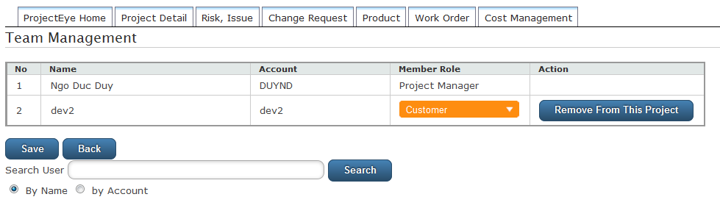

#### 2.3 View Product

##### 2.3.1 Add Product

##### 2.3.2 Update Product

##### 2.3.3 Delete Product

#### 2.4 View Requirement

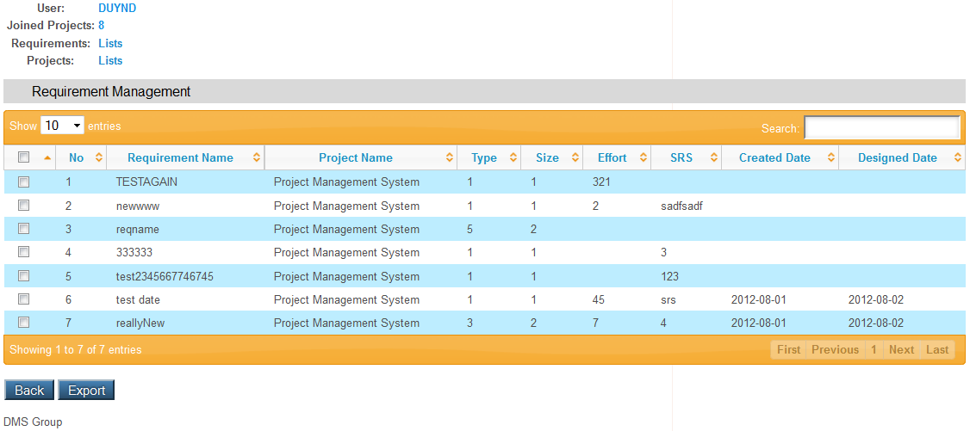

##### 2.4.1 Remove Requirement

##### C:\Users\DuyNgo\Desktop\requirement2.PNG2.4.2 Update Requirement

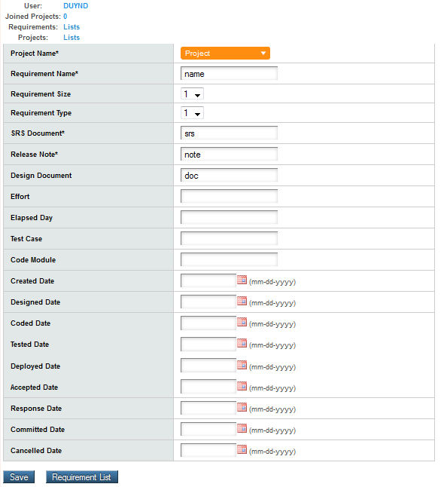

##### 2.4.3 Add Requirement

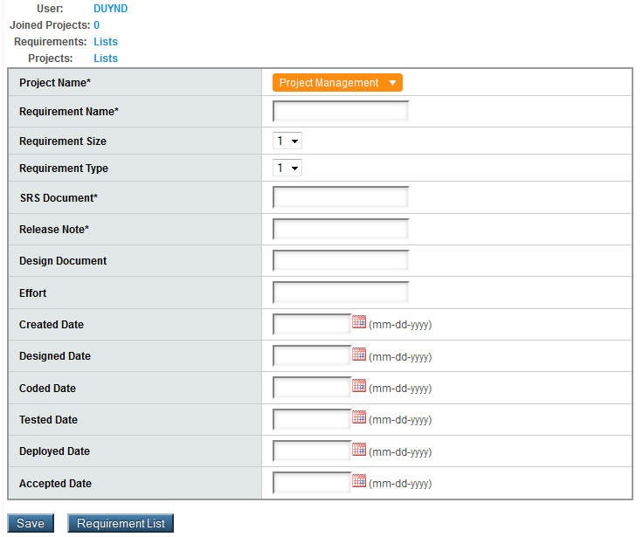

#### 2. 5View Planner

##### 2.5.1 Update task

##### 2.5.2 Add task

##### 2.5.3 Assign task

##### 2.5.4 Delete task

#### 2.6 View Timesheet

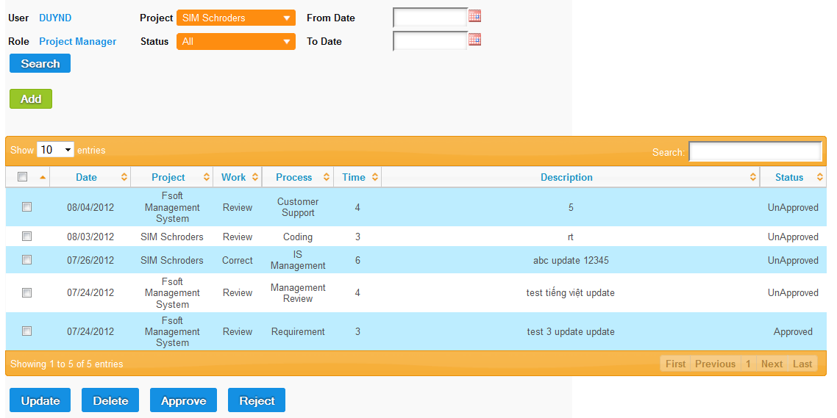

##### 2.6.1 Add Timesheet

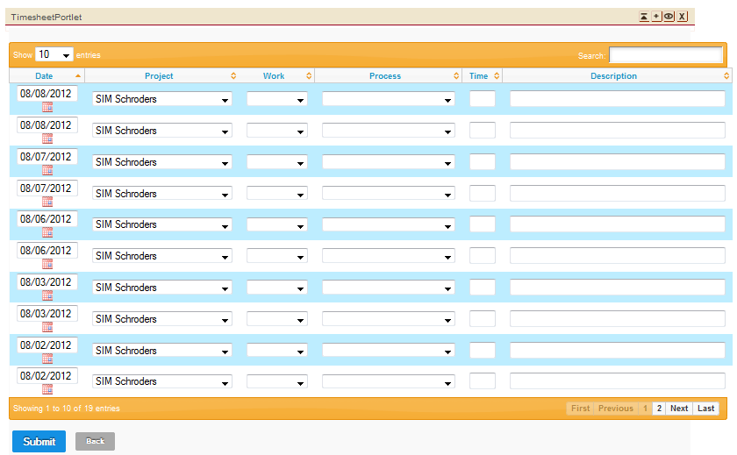

##### 2.6.2 Update Timesheet

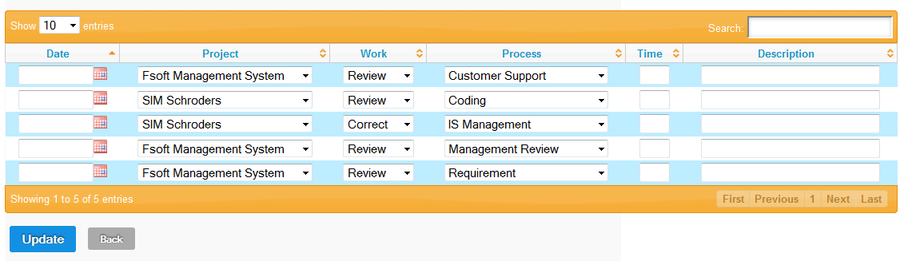

##### 26.3 Delete/Approve/Reject Timesheet

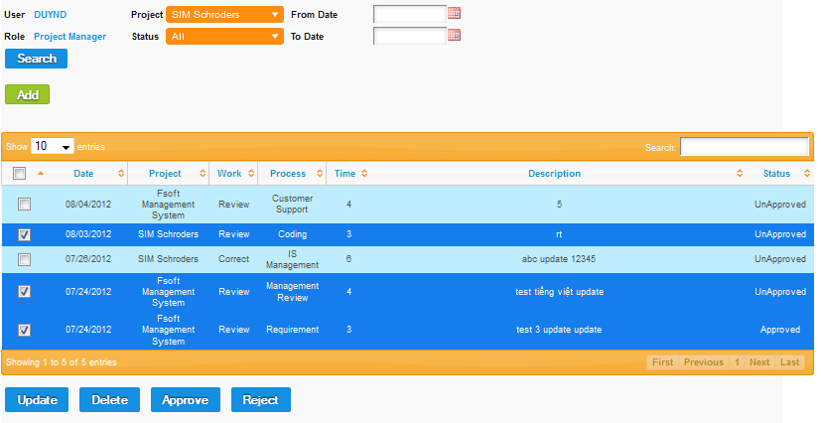

#### 2.7View Defect

##### 2.7.1 Log Defect

##### 2.7.2Assign Defect

### Admin Guide

#### 3.1 Create User

#### 3.2Update User

#### 3.3Delete User

### 4. Android Guide

#### 4.1 Copy .apk install file

#### 4.2 Install app

#### 4.3 View Projects’ status

#### 4.4 View project’s detail status